Illustrative android apps

Create an project
1First set up a project by using AVD manager. Then run it as an Android application from Eclipse. The project can be run either on an AVD or on an active device. To run the project on an AVD, first the project needs to be opened and selected in Eclipse Android Development Tools (ADT), then select Run/Debug Settings, finally click on the project and edit, and now the AVD or active target can be selected (Fig. 1).
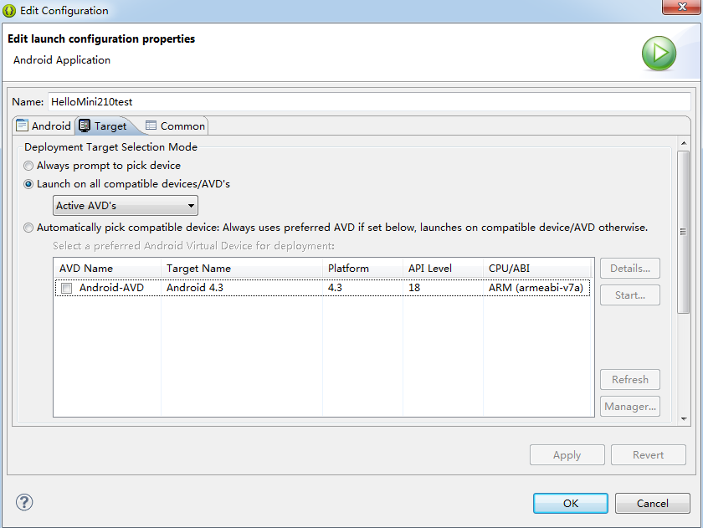
Figure 1. Android apps target device

Android debug bridge (ADB) shell
To access the Linux shell, the location “C:\Program Files\Android\android-sdk\platform- tools” needs to be added to the system variable “path”. Then run ‘cmd’ and type in ‘abd shell’, and thus the shell mode is available.
The command ‘adb devices’ can be used to list the available devices, including both AVDs, which can be launched by using AVD manager, and actual devices.

Install apk location
In adb shell, the command ‘pm set-install-location 0 (1,2)’ can be used to change the location to be installed for the apps. The options ‘0’, ’1’, and ’3’ represent the auto, the internal, and the external storage, respectively. This command may be used to install the apps in the SD card when there is no enough space in the internal storage.

Debug Android apps
When debugging Android apps, if the error 'android.jar has no attachment' shows up, it usually means that the Android source file is not available in the ADT. Then the Android SDK needs to be opened, and the source code needs to be downloaded. Thus, when this error shows up again, click on 'Attach Source' button, and select the Android source with the appropriate level.

